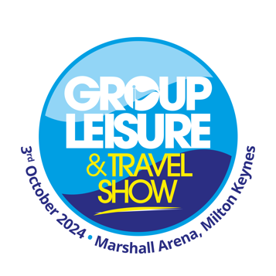

The Group Leisure & Travel Show 2024
Suggested template newsletter/website copy for exhibitors.

[name of company] is looking forward to exhibiting at the Group Leisure & Travel Show, which takes place at the Marshall Arena in Milton Keynes on Thursday 3rd October 2024.
The Group Leisure & Travel Show is the UK’s leading one day exhibition where group travel organisers and coach operators come together to discover ideas, find special offers and learn from industry experts to help them create memorable group trips and holidays.
Every visitor to the show can enjoy some fantastic sessions featuring expert speakers in the Seminar Theatre, including travel journalist, Simon Calder and presenter of TV show Flog It, Paul Martin. Not only could you listen to some interesting ideas and advice, but you could also ask your own questions too.
Visitors love going to the event every year, like Richard Preston, who organises trips for The Valentine Club. Last year he said: “If you go away from the GLT Show with just one idea that you can use it’s a winner and we’ve got more than one idea from the exhibition, so it’s been great.
Patrick Lake of Chippy Active Trips commented: “I come to the GLT Show every year and when you think you’ve seen it all, there’s always something new.”
All visitors and exhibitors can also enjoy a free bacon butty breakfast, along with a free light lunch to enjoy after working up an appetite after finding plenty of new ideas and meeting new contacts.
[add your quote here]
Find out more about the Group Leisure & Travel Show here: https://grouptravelshow.com

