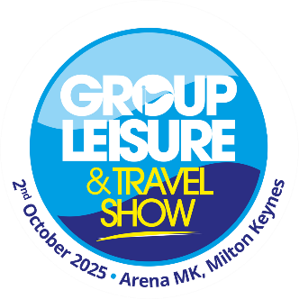

The Group Leisure & Travel Show 2025
Suggested template newsletter/website copy for exhibitors.

[name of company] is looking forward to exhibiting at the Group Leisure & Travel Show, which takes place at the Arena MK in Milton Keynes on Thursday 2nd October 2025.
The Group Leisure & Travel Show is the UK’s leading one day exhibition where group travel organisers and coach operators come together to discover ideas, find special offers and learn from industry experts to help them create memorable group trips and holidays.
Every visitor to the show can enjoy some fantastic sessions from expert speakers in the Seminar Theatre, featuring travel journalist, Simon Calder, Mark Smith from the Antiques Roadshow, and Adam Frost who presents Gardeners’ World. Not only could you listen to some interesting ideas and advice, but you could also ask your own questions too.
Visitors love going to the event every year, like Richard Preston, who organises trips for The Valentine Club. He said: “If you go away from the GLT Show with just one idea that you can use it’s a winner and we’ve got more than one idea from the exhibition, so it’s been great.
Patrick Lake of Chippy Active Trips commented: “I come to the GLT Show every year and when you think you’ve seen it all, there’s always something new.”
All visitors and exhibitors can also enjoy a free bacon butty breakfast, along with a free sandwich lunch to enjoy after working up an appetite and finding plenty of new ideas and meeting new contacts.
[add your quote here]
Find out more about the Group Leisure & Travel Show here: https://grouptravelshow.com

